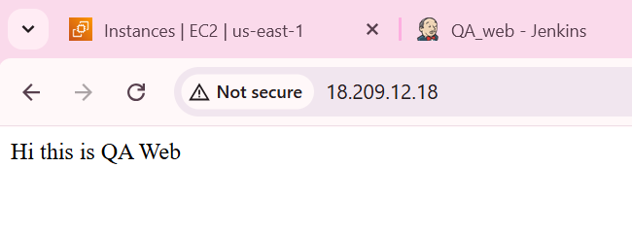

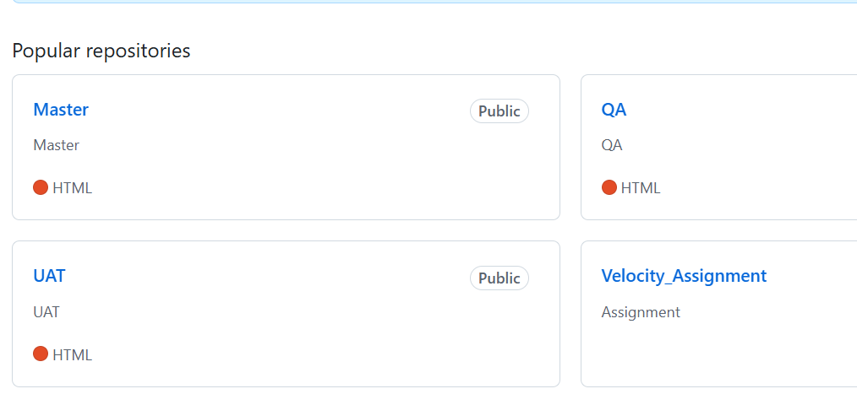

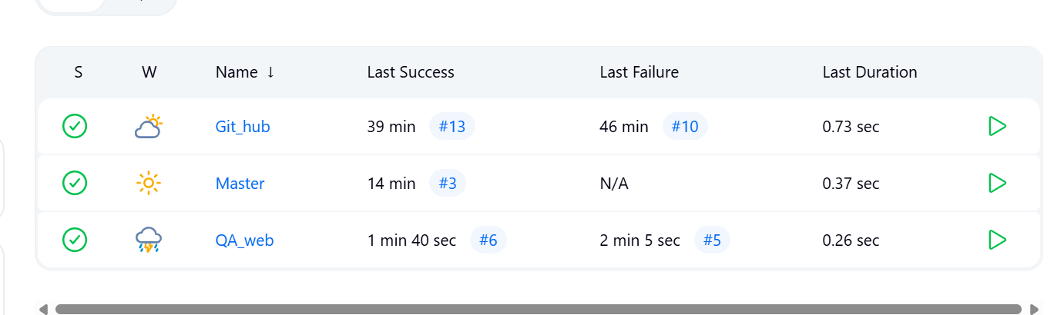

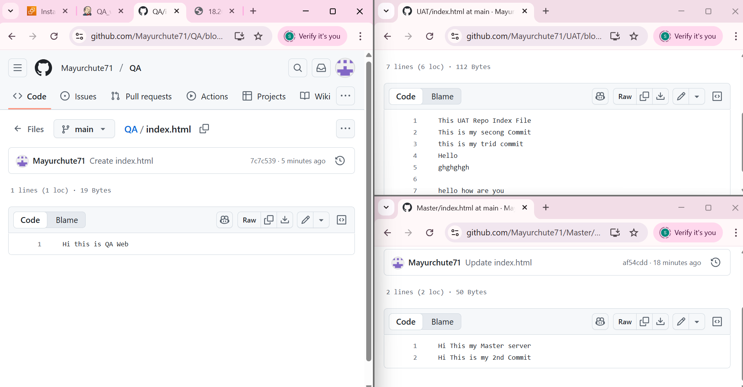

Out Put-1

Started by GitHub push by Mayurchute71

Running as SYSTEM

Building remotely on [Slave-1](http://98.84.107.46:8080/jenkins/computer/Slave-1/) (Qa) in workspace /mnt/Mayur/workspace/Git_hub

[WS-CLEANUP] Deleting project workspace...

[WS-CLEANUP] Deferred wipeout is used...

[WS-CLEANUP] Done

The recommended git tool is: NONE

No credentials specified

Cloning the remote Git repository

Cloning repository <https://github.com/Mayurchute71/UAT.git>

> git init /mnt/Mayur/workspace/Git_hub # timeout=10

Fetching upstream changes from <https://github.com/Mayurchute71/UAT.git>

> git --version # timeout=10

> git --version # 'git version 2.50.1'

> git fetch --tags --force --progress -- <https://github.com/Mayurchute71/UAT.git> +refs/heads/*:refs/remotes/origin/* # timeout=10

> git config remote.origin.url <https://github.com/Mayurchute71/UAT.git> # timeout=10

> git config --add remote.origin.fetch +refs/heads/*:refs/remotes/origin/* # timeout=10

Avoid second fetch

> git rev-parse refs/remotes/origin/main^{commit} # timeout=10

Checking out Revision 2900daee4fa776dd9846ea56db208a8a3835dfb5 (refs/remotes/origin/main)

> git config core.sparsecheckout # timeout=10

> git checkout -f 2900daee4fa776dd9846ea56db208a8a3835dfb5 # timeout=10

Commit message: "Update index.html"

> git rev-list --no-walk ea7d0b31bfc7c1e907583458846fefe896d267d1 # timeout=10

[Git_hub] $ /bin/sh -xe /tmp/jenkins4927913229554602847.sh

+ sudo cp -r /mnt/Mayur/workspace/Git_hub/index.html /var/www/html/

Finished: SUCCESS

OUTPUT -2

Started by GitHub push by Mayurchute71

Running as SYSTEM

Building remotely on [Slave-1](http://98.84.107.46:8080/jenkins/computer/Slave-1/) (Qa) in workspace /mnt/Mayur/workspace/Master

The recommended git tool is: NONE

No credentials specified

> git rev-parse --resolve-git-dir /mnt/Mayur/workspace/Master/.git # timeout=10

Fetching changes from the remote Git repository

> git config remote.origin.url <https://github.com/Mayurchute71/Master.git> # timeout=10

Fetching upstream changes from <https://github.com/Mayurchute71/Master.git>

> git --version # timeout=10

> git --version # 'git version 2.50.1'

> git fetch --tags --force --progress -- <https://github.com/Mayurchute71/Master.git> +refs/heads/*:refs/remotes/origin/* # timeout=10

> git rev-parse refs/remotes/origin/main^{commit} # timeout=10

Checking out Revision af54cddf98f6e13cb861f44d06cf970eef9cd3fc (refs/remotes/origin/main)

> git config core.sparsecheckout # timeout=10

> git checkout -f af54cddf98f6e13cb861f44d06cf970eef9cd3fc # timeout=10

Commit message: "Update index.html"

> git rev-list --no-walk 2c57134e631c1a5b4e2f0dae798a62a163512f89 # timeout=10

[Master] $ /bin/sh -xe /tmp/jenkins9420824102779691835.sh

+ sudo cp -r /mnt/Mayur/workspace/Master/index.html /var/www/html/

Finished: SUCCESS

Output -3

Started by GitHub push by Mayurchute71

Running as SYSTEM

Building remotely on [Slave-1](http://98.84.107.46:8080/jenkins/computer/Slave-1/) (Qa) in workspace /mnt/Mayur/workspace/QA_web

The recommended git tool is: NONE

No credentials specified

> git rev-parse --resolve-git-dir /mnt/Mayur/workspace/QA_web/.git # timeout=10

Fetching changes from the remote Git repository

> git config remote.origin.url <https://github.com/Mayurchute71/QA.git> # timeout=10

Fetching upstream changes from <https://github.com/Mayurchute71/QA.git>

> git --version # timeout=10

> git --version # 'git version 2.50.1'

> git fetch --tags --force --progress -- <https://github.com/Mayurchute71/QA.git> +refs/heads/*:refs/remotes/origin/* # timeout=10

> git rev-parse refs/remotes/origin/main^{commit} # timeout=10

Checking out Revision 7c7c5399b79ae28bc12338f185bad06d5930ba15 (refs/remotes/origin/main)

> git config core.sparsecheckout # timeout=10

> git checkout -f 7c7c5399b79ae28bc12338f185bad06d5930ba15 # timeout=10

Commit message: "Create index.html"

> git rev-list --no-walk 5400e586279f735d4a88b07b0d4e5035edc4f476 # timeout=10

[QA_web] $ /bin/sh -xe /tmp/jenkins5908931459837590973.sh

+ sudo cp -r /mnt/Mayur/workspace/QA_web/index.html /var/www/html/

Finished: SUCCESS